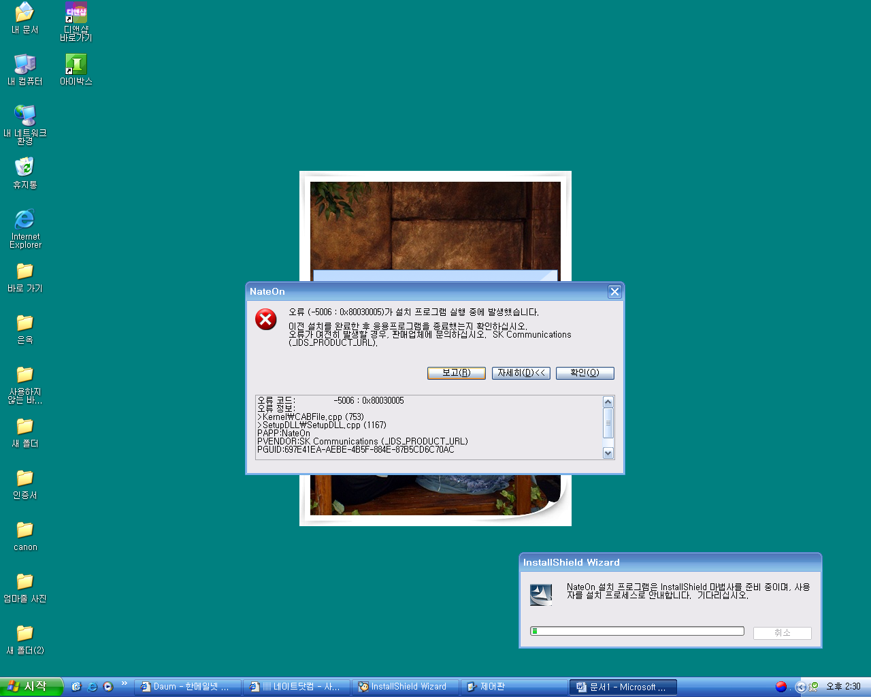

오류 코드: -5006 : 0x80030005
오류 정보:
>Kernel\CABFile.cpp (753)
>SetupDLL\SetupDLL.cpp (1167)
PAPP:NateOn
PVENDOR:SK Communications (_IDS_PRODUCT_URL)
PGUID:697E41EA-AEBE-4B5F-884E-87B5CD6C70AC
$11.0.0.28844PAK
@Windows XP Service Pack 2 (2600) IE 6.0.2900.2180

